* [FREE GUIDES](https://www.digitaldjtips.com/category/tutorials/)

**4-Deck DJ Controllers: The Ultimate Buyer’s Guide 2011**

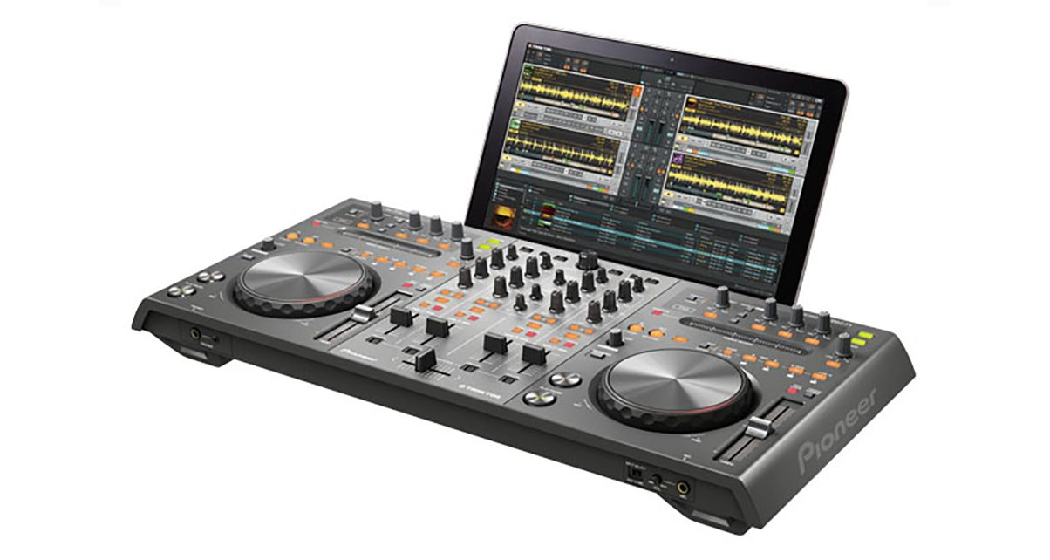



**Phil Morse |Founder & Tutor**

Read time: 13 mins

**LAST UPDATED 28 MARCH, 2018**

 16540

***19 leading four-channel DJ Midi controllers reviewed and rated***

DJs have always loved extra decks and channels. Back in the dark ages when every DJ box had Technics record decks and standard mixer, to find a DJ box with three or even four Technics in it was something special. Today, with all major DJ software now coming with four decks as a minimum, the controllers are catching up. So far 2011 has seen a rake of new four channel hardware hit the market, joining the small number of four-deck controllers that had already become available over the past year or so.

**About this guide**

We’ve rounded up every single major four-channel DJ Midi controller with jogwheels currently on the market (or announced and imminent). They’re listed here in alphabetical order, by manufacturer and then model, and they range in price from pocket money to thousands. As well as rating them, we’ve shown you where to get them from in the USA, UK and Europe, and where we can, worldwide.

Where we haven’t had a chance to use a controller ourselves, we base our round-up notes on the experiences of community members who have, so you can be sure you’re getting an informed opinion.

Having said that, some of them are so new that they’ve only been demoed by the manufacturer at trade shows – so if you can’t even buy a controller yet, don’t expect anyone to be able to give you a full review of what it’s like to use in the real world, because nobody truthfully knows yet.

• Not sure if you want a two or a four-deck controller? Check out two-deck controllers as part of our earlier [DJ Midi Controllers: The Ultimate Buyer’s Guide 2011](http://www.digitaldjtips.com/2010/11/dj-midi-controllers-buyers-guide-2011/).

**Choosing a four-channel DJ controller**

Here are some pointers to help you choose wisely:

* **Most do their mixing internally.** Nearly all of these four-deck controllers have a built-in sound card. They also use “software mixing”. Just because you have four decks (or six, or 99…), there is still just one master stereo output, with al channels mixed together by the software into one master signal. (Therefore if you are buying a controller and sound card separately, it’ll work with a [standard 2 x stereo out DJ sound card](http://www.digitaldjtips.com/2010/11/6-budget-dj-sound-cards/)). However, some give you the ability to output all four decks separately. This is useful if you’d like to use an external 4-channel DJ mixer instead of the built-in mixer in your DJ controller. Make sure you check if this is what you want.
* **They differ in how well they allow you to integrate external sources.** Most give you the ability to plug external sources into the unit – typically CD players or record decks. This means that such a unit could sit at the heart of an analogue/digital DJ set-up. However, the extent to which this functionality is offered differs markedly, from not at all to mind-bogglingly comprehensive. Specifically, check if your external sources can be routed through the software or are mixed with the digital source as an analogue signal (some controllers give you both options, some not) – this would affect direct recording to hard disk, and also whether you can apply software effects to your analogue inputs, for example. Also, some function as standalone mixers (ie with no laptop or software connected), others don’t.
* **They don’t all have four physical channels, and none are truly “four deck”.** While these are advertised as four-deck controllers, none has four jogwheels – you have to switch the deck you are controlling by pressing a button. However, some take this two-deck-switching design further, by only having two sets of volume, EQ etc. controls as well, so the mixer section looks like a two-channel mixer rather than a four-channel mixer. This gives a simpler, cheaper design and more portability at the expense of being able to “ride” all four faders simultaneously without switching. While they use clever firmware, typically with colour coding and mappings that make switching fader/knob control from one deck to another quite intuitive, the two-deck route is inevitably less intuitive than having four full channels. Decide if this is an issue for you and choose accordingly.
* **They tend to be bigger and heavier than their two-deck counterparts.** These generally aren’t the tiniest of controllers. To squeeze the four-deck functionality and accompanying extra features into a box and make it easy to use takes space, and indeed some manufacturers have decided to spread everything out and not worry too much about the size or weight of their units. Notably, four physical channels takes up more space than two. Weight up how portable you want your controller to be with how fiddly it is to DJ on four decks from a small unit to find the right compromise for you.
* **They don’t all have four-deck DJ software supplied with them.** Check that the software that comes with your controller lets you use four decks out of the box. Some doesn’t. You’ll want to upgrade to a full version of the DJ software that comes with your controller should it happen to come with a starter or “LE” (light edition) software package anyway, as these versions are deliberately limited in features to encourage you to buy the full package, but not being able to use all four decks out of the box is a limitation too far in our view.

If you have any specific questions or queries, please come and post on our [Facebook Discussions Page](http://www.facebook.com/digitaldjtips?v=app_2373072738), remembering to “Like” the page while you’re there. We live and breathe this stuff and we want to help.

Finally, please check all specifications, dimensions, compatibilities and so on for yourself before buying. We try our hardest, but we’re only human and just because we say something might be suitable for you, doesn’t mean it is. Do your homework – it’s part of the fun! And happy controller hunting.

**The controllers…**

[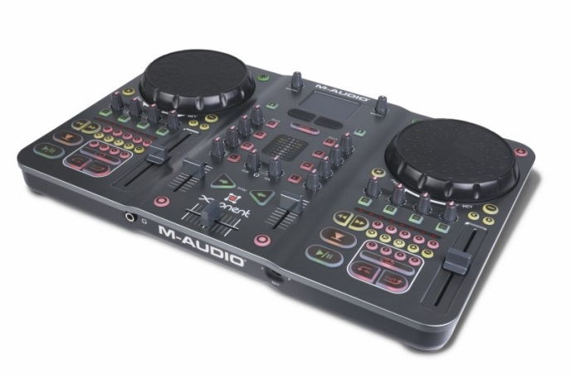](http://cdn.digitaldjtips.com/app/uploads/2011/02/09152620/torq_Xponent.jpg)Avid’s Torq Xponent now comes with Torq 2.0 four-deck software giving this established controller full four-deck capability for the first time.

**Avid/M-Audio Torq Xponent**

*Price:* [US$399](http://www.amazon.com/gp/product/B000N7ZAIC?ie=UTF8&tag=pbmo-20&linkCode=as2&camp=1789&creative=390957&creativeASIN=B000N7ZAIC) / [£372](http://www.juno.co.uk/products/m-audio-torq-xponent-advanced-dj-performance-production-system-version-1-5/341545-01/?currency=GBP&ref=ddjt) / [€437](http://www.juno.co.uk/products/m-audio-torq-xponent-advanced-dj-performance-production-system-version-1-5/341545-01/?currency=EUR&ref=ddjt)  
*Rating:* [rating=4]

Supplied software: Torq 2.0 (free upgrade from 1.5); Decks usable with supplied software: 4; Sound card: yes; Phono/line inputs: no; Physical channels: 2; Booth/record out: yes; Mic in: no; Power: USB; Size & weight: 18 x 12 x 2.6″ (458 x 306 x 65mm), 8.2lb (3.7kg)

*They say:*The professional-grade Torq Xponent system seamlessly integrates high-performance DJ software with a fully functional hands-on controller.

*We say:*Quality full control system from Avid (previously M-Audio). High-end features include on-the-fly tempo-synced sampling, lots of FX and new in 2.0, 4-deck control. In some ways it’s forerunner to the Traktor Kontrol S4. No extra inputs or outputs though.

*See it at:* [Amazon.com](http://www.amazon.com/gp/product/B000N7ZAIC?ie=UTF8&tag=pbmo-20&linkCode=as2&camp=1789&creative=390957&creativeASIN=B000N7ZAIC), [Juno.co.uk (UK, rest of Europe & world)](http://www.juno.co.uk/products/m-audio-torq-xponent-advanced-dj-performance-production-system-version-1-5/341545-01/?ref=ddjt)

[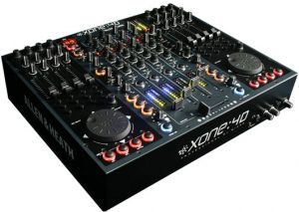](http://cdn.digitaldjtips.com/app/uploads/2011/02/09152615/allen-heath-xone-4d.jpg)Nobody will accuse you of playing with toys if you turn up at a gig with one of these.

**Allen & Heath Xone:4D**

*Price:* [US$2,200](http://www.amazon.com/gp/product/B001V6V34O?ie=UTF8&tag=pbmo-20&linkCode=as2&camp=1789&creative=390957&creativeASIN=B001V6V34O) / [£1,448](http://www.juno.co.uk/products/allen-heath-xone-4d-professional-digital-dj-mixer-controller-20-channel-usb-audio-interface-graphite-grey/350246-01/?currency=GBP&ref=ddjt) / [€1,992](http://www.juno.co.uk/products/allen-heath-xone-4d-professional-digital-dj-mixer-controller-20-channel-usb-audio-interface-graphite-grey/350246-01/?currency=EUR&ref=ddjt)  
*Rating:*[rating=4]

Supplied DJ software: Traktor LE, Ableton Live demo; Decks usable with supplied software: 2; Sound card: yes; Phono/line inputs: 4; Physical channels: 4; Booth/record out: yes; Mic in: yes; Power: external; Size & weight: 17 x 14 x 3.5″ (431 x 356 x 89mm), 11lb (5kg)

*They say:* The Xone:4D continues the seamless integration of computer-based digital media into the traditional DJ workspace, but with a further enhanced feature set.

*We say:* Highly professional unit aimed at the very high end with a 10-in/10-out sound card and brilliant filters. Not the best for portable digital DJs because of its size and weight, can’t scratch well on it, plus you’ll need a pro software package to use all 4 decks.

*See it at:*[Amazon.com](http://www.amazon.com/gp/product/B001V6V34O?ie=UTF8&tag=pbmo-20&linkCode=as2&camp=1789&creative=390957&creativeASIN=B001V6V34O) / [Juno.co.uk (UK, rest of Europe & world)](http://www.juno.co.uk/products/allen-heath-xone-4d-professional-digital-dj-mixer-controller-20-channel-usb-audio-interface-graphite-grey/350246-01/?ref=ddjt)

[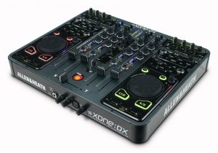](http://cdn.digitaldjtips.com/app/uploads/2010/11/09153016/allen-heath-xone-dx.jpg)Fully featured, fantastic looking, light, strong, compact and a scream to use – It\’s fair to say we like the Xone:DX.

**Allen & Heath Xone:DX**

*Price:*[US$999](http://www.amazon.com/gp/product/B003JLMWPI?ie=UTF8&tag=pbmo-20&linkCode=as2&camp=1789&creative=390957&creativeASIN=B003JLMWPI) / [£998](http://www.juno.co.uk/products/allen-heath-xone-dx-midi-controller-usb-soundcard/369733-01/?currency=GBP&ref=ddjt) / [€1170](http://www.juno.co.uk/products/allen-heath-xone-dx-midi-controller-usb-soundcard/369733-01/?currency=EUR&ref=ddjt)  
*Rating:* [rating=5]

Supplied DJ software: Serato ITCH. Sound card: yes; Phono/line inputs: 4; Physical channels: 4; Booth/record out: yes; Mic in: yes; Power: external; Size & weight: 15 x 14 x 2″ (381 x 356 x 51mm), 12lb (5.5kg)

*They say:*Professional Midi USB controllers integrated with 4-deck Serato ITCH software. The most powerful ITCH controller on the planet.

*We say:*Thinner, lighter and more portable than the Xone:4D and coming tightly integrated with the elegant Serato ITCH pro software, this is a truly complete controller, let down only slightly by old-style jogwheels. [Read more](http://www.digitaldjtips.com/2011/01/allen-heath-xone-dx-review/)

*See it at:*[Amazon.com](http://www.amazon.com/gp/product/B003JLMWPI?ie=UTF8&tag=pbmo-20&linkCode=as2&camp=1789&creative=390957&creativeASIN=B003JLMWPI), [Juno.co.uk (UK, rest of Europe & world)](http://www.juno.co.uk/products/allen-heath-xone-dx-midi-controller-usb-soundcard/369733-01/?ref=ddjt)

[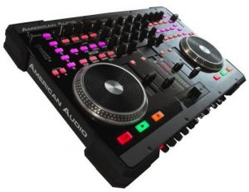](http://cdn.digitaldjtips.com/app/uploads/2011/02/09152620/american-audio-vms4.jpg)It’s one of the most flexible and fully featured DJ controllers in our round up, but it’s not the best built.

**American Audio VMS4**

*Price:*[US$455](http://www.amazon.com/gp/product/B003RAB97I?ie=UTF8&tag=pbmo-20&linkCode=as2&camp=1789&creative=390957&creativeASIN=B003RAB97I) / [£327](http://www.thomann.de/index.html?partner_id=39004&page=gb/american_audio_vms4.htm) / [€377](http://www.thomann.de/index.html?partner_id=39004&page=gb/american_audio_vms4.htm)  
*Rating:*[rating=3]

Supplied DJ software: Virtual DJ LE; Decks usable with supplied software: 4; Sound card: yes; Phono/line inputs: 4; Physical channels: 4; Booth/record out: yes; Mic in: yes; Power: USB/external; Size & weight: 19.1 x 12.6 x 2.7″ (487 x 320 x 70mm), 13lb (6kg)

*They say:* The VMS4 is a 4-Channel “MIDILOG™” controller that fuses both Midi (Midi software) and analog audio control (CD players, turntables etc.) into one unit.

*We say:* You get a LOT for your money here, like 2 EQed mics, XLR outs, flexible ins, booth control, and great flexibility. Fair quality build reflected in the price.

*See it at:* [Amazon.com](http://www.amazon.com/gp/product/B003RAB97I?ie=UTF8&tag=pbmo-20&linkCode=as2&camp=1789&creative=390957&creativeASIN=B003RAB97I), [Thomann (UK & rest of Europe)](http://www.thomann.de/index.html?partner_id=39004&page=gb/american_audio_vms4.htm)

[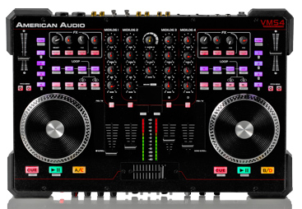](http://cdn.digitaldjtips.com/app/uploads/2011/02/09152619/american-audio-vms4T-review.png)The American Audio VMS4T is pretty much identical to the VMS4, only closely tied to Traktor software and offering four-deck functionality out of the box.

**American Audio VMS4T**

*Price:*[*US$599*](http://www.musictrends.com/vms4-traktor-p-13968.html)  
*Rating:*[rating=3]

Supplied DJ software: ; Decks usable with supplied software: 4; Sound card: yes; Phono/line inputs: 4; Physical channels: 4; Booth/record out: yes; Mic in: yes; Power: USB/external; Size & weight: 19.1 x 12.6 x 2.7″ (487 x 320 x 70mm), 13lb (6kg)

*They say:* We’ve taken the VMS4 and kept all of the features that have made it such a hit over the past year, like the mouse pad and the all-metal jogwheels, and paired it with Traktor software

*We say: If you like the original VMS4 but want to use it with Traktor, this is obviously for you. Limited availability means you’ll pay more for it than the Virtual DJ version, though.*

*See it at:* [Music Trends](http://www.musictrends.com/vms4-traktor-p-13968.html)

[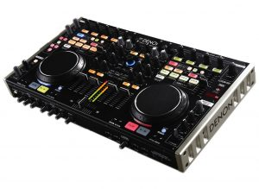](http://cdn.digitaldjtips.com/app/uploads/2011/01/09152707/denon-dn-mc6000-review.jpg)Taking its style cues from previous Denon DJ equipment, the DN-MC6000 is high-tech but workmanlike, and packs a lot of features into its compact case.

**Denon DN-MC6000**

*Price:*[*US$799*](http://www.amazon.com/gp/product/B004H7YU12?ie=UTF8&tag=pbmo-20&linkCode=as2&camp=1789&creative=390957&creativeASIN=B004H7YU12)*/*[*£679*](http://www.juno.co.uk/products/denon-dn-mc6000-dj-controller/402351-01/?currency=GBP&ref=ddjt)*/*[*€795*](http://www.juno.co.uk/products/denon-dn-mc6000-dj-controller/402351-01/?currency=EUR&ref=ddjt)  
*Rating:*[rating=5]

Supplied DJ software: Virtual DJ 7 LE, Traktor LE; Decks usable with supplied software: 4 (Virtual DJ) / 2 (Traktor); Sound card: yes; Phono/line inputs: 4; Physical channels: 4; Booth/record out: yes; Mic in: yes; Power: External; Size & weight: 18.1 x 10 x 2? (460 x 254 x 51mm), 10.3lbs (4.7kg)

*They say:* With an astounding amount of features, real-time channel matrix operation, slim tabletop design, state-of-the-art solid steel chassis construction and quality sound, the DN-MC6000 is one of Denon DJ’s flagship controllers.

*We say:* For serious multi-format DJs, pro mobile DJs, and even for smaller DJ booths, the Denon DN-MC6000 would be ideal. It’s the most flexible 4-channel DJ controller we’ve tested at Digital DJ Tips so far, and overall is a quality piece of kit. [Read more](http://www.digitaldjtips.com/2011/01/review-denon-dn-mc6000-dj-midi-controller/)

*See it at:* [Amazon.com](http://www.amazon.com/gp/product/B004H7YU12?ie=UTF8&tag=pbmo-20&linkCode=as2&camp=1789&creative=390957&creativeASIN=B004H7YU12), [Juno.co.uk (UK, rest of Europe & world)](http://www.juno.co.uk/products/denon-dn-mc6000-dj-controller/402351-01/?ref=ddjt)

[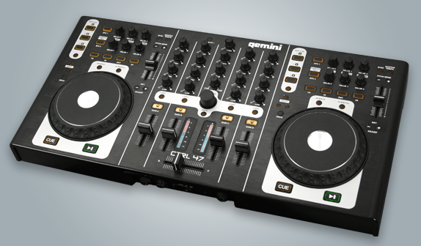](http://cdn.digitaldjtips.com/app/uploads/2011/02/09152619/gemini-ctrl-47.png)The Gemini CTRL-47 looks to be well-built and functional, but we’ve yet to use one ourselves.

**Gemini CTRL-47**

*Price:*[TBC](http://www.djdeals.com/geminiCTRL47.htm)  
*Rating:*[rating=3]

Supplied DJ software: Virtual DJ 7 LE; Decks usable with supplied software: 4; Sound card: yes; Phono/line inputs: 1; Physical channels: 4; Booth/record out: yes; Mic in: yes; Power: external; Size & weight: not known

*They say:* Gemini wrote the book on DJing back in 1974, but now we’re rewriting it. “Digital DJ” was once a bad-word amongst DJs, embodying the loss of control and feel over their DJing trade. But the Gemini CTRL-47 was designed for DJs by the company who knows them better than anyone.

*We say:* We’re awaiting a review sample of this controller from a veteran DJ brand so our score may change. It looks cleanly laid out, functional and well-built; we’ll let you know if it’s worth the cash once we’ve used one and got a street price.

*See it at:* Not listed in stores yet

[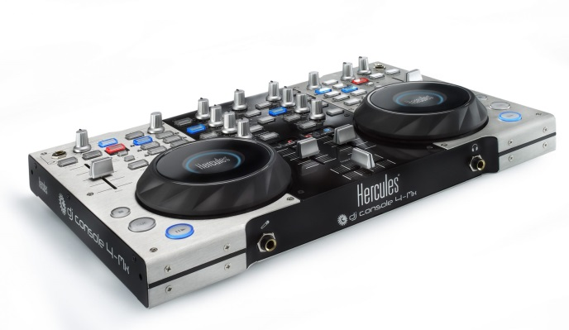](http://cdn.digitaldjtips.com/app/uploads/2010/11/09153014/hercules-dj-console-4-mx.jpg)The DJ Console 4-Mx is stylistically an improvement on the DJ Console RMX, its predecessor, while still retaining the Hercules look and feel to the knobs and buttons.

**Hercules DJ Console 4-Mx**

*Price:*[US$475](http://www.amazon.com/gp/product/B0047FS5MY?ie=UTF8&tag=pbmo-20&linkCode=as2&camp=1789&creative=390957&creativeASIN=B0047FS5MY) / [£410](http://www.amazon.co.uk/gp/product/B0045X9CMA?ie=UTF8&tag=didjti-21&linkCode=as2&camp=1634&creative=19450&creativeASIN=B0045X9CMA)  
*Rating:*[rating=4]

Supplied DJ software: Virtual DJ LE; Decks usable with supplied software: ; Sound card: yes: Phono/line inputs: 2; Physical channels: 2; Booth/record out: no; Mic-in: yes; Power: USB; Size & weight: 15 x 9.8 x 2.6″ (381 x 249 x 63mm), 10lb (4.5kg)

*They say:*Large metal DJ controller with built-in audio and large jog wheels. Professional mix station for mobile and club DJs with included carry bag.

*We say:*The next generation of their dependable DJ Console RMX controller. Sensitive jog wheels are excellent, and 4 decks future-proofs it. Still somewhat clunky though. [Read more](http://www.digitaldjtips.com/2011/02/review-hercules-dj-console-4-mx/)

*See it at:*[Amazon.com](http://www.amazon.com/gp/product/B0047FS5MY?ie=UTF8&tag=pbmo-20&linkCode=as2&camp=1789&creative=390957&creativeASIN=B0047FS5MY), [Amazon.co.uk](http://www.amazon.co.uk/gp/product/B0045X9CMA?ie=UTF8&tag=didjti-21&linkCode=as2&camp=1634&creative=19450&creativeASIN=B0045X9CMA)

[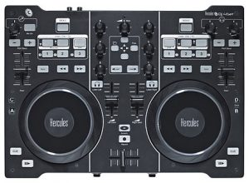](http://cdn.digitaldjtips.com/app/uploads/2011/02/09152618/dj4set-hercules.jpg)The Hercules DJ 4Set won’t be built to pro standards – but the jogwheels are very good, and at this price point that makes all the difference.

**Hercules DJ 4Set**

*Price:*[US$249](http://www.zzounds.com/item--HERDJ4SET) / [£229](http://www.juno.co.uk/products/hercules-dj-4set-dj-controller-with-built-in-audio-interface/417288-01/?currency=GBP&ref=ddjt) / [€268](http://www.juno.co.uk/products/hercules-dj-4set-dj-controller-with-built-in-audio-interface/417288-01/?currency=EUR&ref=ddjt)

*Rating:*[rating=4]

Supplied DJ software: Virtual DJ 7 LE; Decks usable with supplied software: 4; Sound card: yes; Phono/line inputs: 0; Physical channels: 2; Booth/record out: no; Mic in: yes; Power: USB; Size & weight: 13.7 x 9.8 x 2″ (350 x 250 x 50mm), 4.4lb (2kg)

*They say:* Large DJ controller with built-in audio output. The Hercules DJ 4Set combines the functions and feel of a pro controller with the simplicity users need to host memorable parties all night long. All-nighters only.

*We say:* Looks like this is aimed squarely at the Mixtrack Pro, but with the benefit of being able to control 4 decks. Jogwheels are the same as the 4-Mx, which means they’re very good.

*See it at:* [ZZsounds (US)](http://www.zzounds.com/item--HERDJ4SET), [Juno.co.uk (UK, rest of Europe & world)](http://www.juno.co.uk/products/hercules-dj-4set-dj-controller-with-built-in-audio-interface/417288-01/?ref=ddjt)

[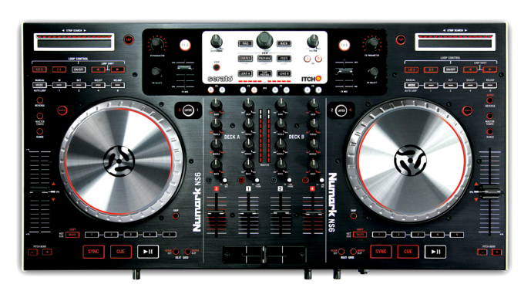](http://cdn.digitaldjtips.com/app/uploads/2011/02/09152618/numark-ns6.png)The Numark NS6 is built to the same standards as the NS7, V7 and X5, but doesn’t look as clean-cut, due to the features crammed into it.

**Numark NS6**

*Price:*[US$949](http://www.amazon.com/gp/product/B004S1PZP2/ref=as_li_ss_tl?ie=UTF8&tag=pbmo-20&linkCode=as2&camp=217145&creative=399373&creativeASIN=B004S1PZP2) / [£799](http://www.juno.co.uk/products/numark-ns6-dj-controller/416419-01/Juno:%20?currency=GBP&ref=ddjt) / [€905](http://www.juno.co.uk/products/numark-ns6-dj-controller/416419-01/Juno:%20?currency=EUR&ref=ddjt)  
*Rating:*[rating=5]

Supplied DJ software: Serato ITCH; Decks usable with supplied software: 4; Sound card: yes; Phono/line inputs: 4 line, 2 phono; Physical channels: 4; Booth/record out: yes; Mic in: yes; Power: external; Size & weight: 24 x 13.5 x 2.5″ (600 x 340 x 65mm), 14lbs (6.3kg)

*They say:* NS6 is the first truly pro-grade DJ controller and standalone four-channel mixer with effects. Simply put, there has never been this much versatility and control available for professional DJs.

*We say:* With the build quality of the excellent NS7, and jogwheels as good as claimed (even though they look a bit plasticky at the edges), this is a worth high-end contender to the Allen & Heath Xone:DX, which is the only other Serato ITCH four-deck controller there is. [Read more](http://www.digitaldjtips.com/2011/07/numark-ns6-review-dj-controller/)

*See it at:* [Amazon.com](http://www.amazon.com/gp/product/B004S1PZP2/ref=as_li_ss_tl?ie=UTF8&tag=pbmo-20&linkCode=as2&camp=217145&creative=399373&creativeASIN=B004S1PZP2), [Juno (UK)](http://www.juno.co.uk/products/numark-ns6-dj-controller/416419-01/?currency=GBP&ref=ddjt) / [Juno (rest of Europe & world)](http://www.juno.co.uk/products/numark-ns6-dj-controller/416419-01/?currency=EUR&ref=ddjt)

[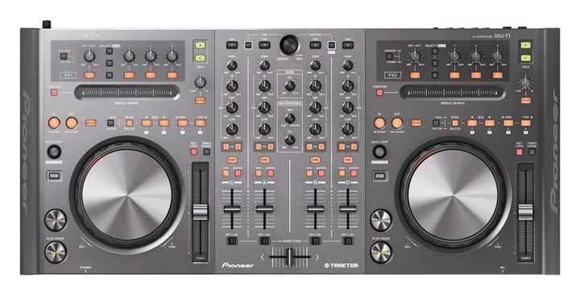](http://cdn.digitaldjtips.com/app/uploads/2011/01/09152806/pioneer-ddj-t1-dj-controller-review.jpg)The Pioneer DDJ-T1 DJ controller is a heavyweight addition to this suddenly crowded end of the market.

**Pioneer DDJ-T1**

*Price:*[US$999](http://www.amazon.com/gp/product/B004JPYORC?ie=UTF8&tag=pbmo-20&linkCode=as2&camp=1789&creative=390957&creativeASIN=B004JPYORC) / [£899](http://www.juno.co.uk/products/pioneer-ddj-t1-traktor-all-in-one-4-channel-dj-controller-with-integrated-dj-functions-traktor-dj-software/415665-01/?currency=GBP&ref=ddjt) / [€1,053](http://www.juno.co.uk/products/pioneer-ddj-t1-traktor-all-in-one-4-channel-dj-controller-with-integrated-dj-functions-traktor-dj-software/415665-01/?currency=EUR&ref=ddjt)  
*Rating:*[rating=3]

Supplied DJ software: Traktor Pro; Decks usable with supplied software: 4; Sound card: yes; Phono/line inputs: 1 (emergency thru); Physical channels: 4; Booth/record out: no; Mic in: yes; Power: external; Size & weight: 26.8 x 12.5 x 3.7″ (680 x 317 x 94mm), 10.8lb (4.9kg)

*They say:* Designed for use with the Traktor software, which makes it possible for DJs to play with music files on a computer. The controller has the same operability and layout as our professional DJ equipment, so you can give high-level performances using Traktor DJ software.

*We say:* The fact that it’s from Pioneer will open doors for this unit. It’s very wide, well laid out and has a few innovations like the strip search function, but is not particularly well featured otherwise, with few external inputs and no booth out, for instance. For Pioneer fans it will feel great, but the jury’s out on this for value.

*See it at:* [Amazon.com](http://www.amazon.com/gp/product/B004JPYORC?ie=UTF8&tag=pbmo-20&linkCode=as2&camp=1789&creative=390957&creativeASIN=B004JPYORC), [Juno.co.uk (UK, rest of Europe & world)](http://www.juno.co.uk/products/pioneer-ddj-t1-traktor-all-in-one-4-channel-dj-controller-with-integrated-dj-functions-traktor-dj-software/415665-01/?ref=ddjt)

[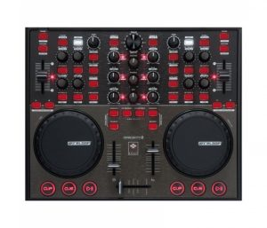](http://cdn.digitaldjtips.com/app/uploads/2011/02/09152617/digital-jockey-2-controller-edition-reloop.jpg)The Reloop Digital Jockey 2 Controller Edition is a good-looking and well laid-out DJ controller.

**Reloop Digital Jockey 2 Controller Edition**

*Price:*[US$352](http://www.juno.co.uk/products/363990-01.htm?currency=USD&ref=ddjt) / [£218](http://www.juno.co.uk/products/363990-01.htm?currency=GBP&ref=ddjt) / [€256](http://www.juno.co.uk/products/363990-01.htm?currency=EUR&ref=ddjt)  
*Rating:* [rating=3]

Supplied software: Traktor LE; Decks usable with supplied software: 2; Sound card: no; Physical channels: 2; Power: USB/external; Size & weight: 13 x 11.6 x 1.5″ (370 x 38 x 295mm), 5.5lb (2.5kg)

*They say:*With the Digital Jockey 2 Reloop gives Traktor DJs a controller that will make sound become truly tangible: A perfect team up.

*We say:*Sturdy build, a few complaints about the cue buttons failing though. Nice size, but no sound card. Well featured and professional looking, but not the best value at this price unless you already have a sound card, as you’ll need extra software too. [Read more](http://www.digitaldjtips.com/2010/10/reloop-digital-jockey-2-dj-controller-review/)

*See it at:*[Juno.co.uk (UK, rest of Europe & world)](http://www.juno.co.uk/products/363990-01.htm?ref=ddjt)

[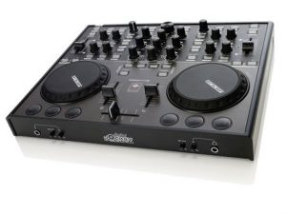](http://cdn.digitaldjtips.com/app/uploads/2011/02/09152616/reloop-digital-jockey-2-interface-edition.jpg)The interface edition is practically identical to the controller edition except of course for the sound card elements like mike and headphones inputs and RCAs round the back.

**Reloop Digital Jockey 2 Interface Edition**

*Price:*[US$396](http://www.amazon.com/gp/product/B00418F3NG?ie=UTF8&tag=pbmo-20&linkCode=as2&camp=1789&creative=390957&creativeASIN=B00418F3NG) / [£298](http://www.juno.co.uk/products/reloop-digital-jockey-2-interface-edition-version-2/363991-01/?currency=GBP&ref=ddjt) / [€350](http://www.juno.co.uk/products/reloop-digital-jockey-2-interface-edition-version-2/363991-01/?currency=EUR&ref=ddjt)  
*Rating:* [rating=3]

Supplied software: Traktor LE; Decks usable with supplied software: 2; Sound card: yes; Phono/line inputs: 1; Physical channels: 2; Booth/record out: no; Mic in: yes; Power: USB/external; Size and weight: 13 x 11.6 x 1.5″ (370 x 38 x 295 mm), 6lb (2.7kg)

*They say:* With the Digital Jockey 2, Reloop gives Traktor DJs a controller that will make sound become truly tangible: A perfect team up.

*We say:*Adds a soundcard, touch-sensitive jog wheels and input for one external source to the features of the interface edition. An extra line in would have been good – why just one?

*See it at:* [Amazon.com](http://www.amazon.com/gp/product/B00418F3NG?ie=UTF8&tag=pbmo-20&linkCode=as2&camp=1789&creative=390957&creativeASIN=B00418F3NG), [Juno.co.uk (UK, rest of Europe & world)](http://www.juno.co.uk/products/reloop-digital-jockey-2-interface-edition-version-2/363991-01/?ref=ddjt)

[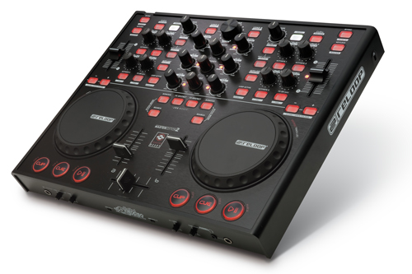](http://cdn.digitaldjtips.com/app/uploads/2011/02/09152616/Reloop-Digital-Jockey-2-Master-Edition.jpg)The Reloop Digital Jockey 2 Master Edition packs a lot of technology into the same case as the rest of the Reloop controller series.

**Reloop Digital Jockey 2 Master Edition**

*Price:*[US$632](http://www.juno.co.uk/products/reloop-digital-jockey-2-master-edition/389796-01/?currency=USD&ref=ddjt) / [£389](http://www.juno.co.uk/products/reloop-digital-jockey-2-master-edition/389796-01/?currency=USD&ref=ddjt) / [€445](http://www.juno.co.uk/products/reloop-digital-jockey-2-master-edition/389796-01/?currency=USD&ref=ddjt)  
*Rating:* [rating=4]

Supplied software: Traktor LE; Decks usable with supplied software: 2; Sound card: yes; Phono/line inputs: 2; Physical channels: 2; Booth/record out: yes; Mic in: yes; power: external; Size & weight: 13 x 11.6 x 1.5″ (370 x 38 x 295 mm), 6lb (2.7kg)

*They say:* All the critically acclaimed controller features are still on board, but now it comes with symmetric output, booth output and standalone mixing.

*We say:*Sophisticated channel routing, club, booth and master outputs, works as an analogue mixer without laptop plugged in, and nice and compact meaning easier to carry around than many of these. A good contender.

*See it at:* [Juno.co.uk (UK, rest of Europe & world)](http://www.juno.co.uk/products/reloop-digital-jockey-2-master-edition/389796-01/)

[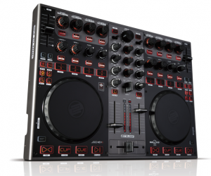](http://cdn.digitaldjtips.com/app/uploads/2011/02/09152617/reloop-jockey-3-master-edition.png)The Reloop Jockey 3 Master Edition is completely metal cased and has excellent jogwheels. It is shaping up to be a desirable new controller.

**Reloop Jockey 3 Master Edition**

*Price:*[US$802](http://www.juno.co.uk/products/reloop-digital-jockey-3-me-mission-iii/417296-01/?currency=GBP&ref=ddjt) / [£499](http://www.juno.co.uk/products/reloop-digital-jockey-3-me-mission-iii/417296-01/?currency=GBP&ref=ddjt) / [£584](http://www.juno.co.uk/products/reloop-digital-jockey-3-me-mission-iii/417296-01/?currency=GBP&ref=ddjt)  
*Rating:*[rating=4]

Supplied DJ software: Traktor 2 LE; Decks usable with supplied software: 4 (expected); Sound card: yes; Phono/line inputs: 2; Physical channels: 2; Booth/record out: yes; Mic in: yes; Power: external; Size & weight: 16.5 x 11.8 x 1.6″ (420 x 300 x 42mm), 9.9lb (4.5kg),

*They say:* Since the introduction of the highly successful Digital Jockey series, Reloop stands for digital tradition and consistent further development on the DJ controller market. With MISSION III, namely the Jockey 3, the Digital Jockey series will be newly defined.

*We say:* Well laid out, excellent build quality, great jog wheels, lots of inputs and outputs, and tight integration with 4-deck Traktor. Right blend of size, weight, quality and feature make this a desirable controller, but we’ve not tested it yet.

*See it at:* [Juno.co.uk (UK, rest of Europe & world)](http://www.juno.co.uk/products/reloop-digital-jockey-3-me-mission-iii/417296-01/?currency=GBP&ref=ddjt)

[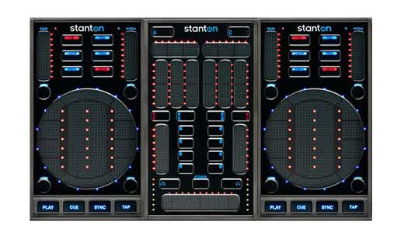](http://cdn.digitaldjtips.com/app/uploads/2011/02/09152616/StantonSCS3DJController.jpg)One of the best looking little controllers out there, with three parts that clip together magnetically.

**Stanton SCS3 DJ Control System**

*Price:*[US$499](http://www.amazon.com/gp/product/B002TP500E?ie=UTF8&tag=pbmo-20&linkCode=as2&camp=1789&creative=390957&creativeASIN=B002TP500E) / [£379](http://www.dolphinmusic.co.uk/product/47327-stanton-sc-system-3-controller-package.html?locale=en_GB) / [€433](http://www.dolphinmusic.co.uk/product/47327-stanton-sc-system-3-controller-package.html?locale=de_DE)  
*Rating:*[rating=5]

Supplied software: Traktor LE; Decks usable with supplied software: ; Sound card: no; Physical channels: 2; Power: USB; Size & weight: 14.2 x 8.5 x 1.4in (360 x 216 x 35mm), 3.5lb (1.6kg)

*They say:* The most innovative, completely mobile Midi control solution available, with 2 touch-sensitive control surfaces for customizable software control.

*We say:*Compact, innovative, clever and capable, this is a bold and well thought-out innovation from Stanton. True portable 4-channel DJing – it even splits up into three parts for stashing. You’ll need a sound card though.

*See it at:* [Amazon.com](http://www.amazon.com/gp/product/B002TP500E?ie=UTF8&tag=pbmo-20&linkCode=as2&camp=1789&creative=390957&creativeASIN=B002TP500E), [Dolphin Music (UK)](http://www.dolphinmusic.co.uk/product/47327-stanton-sc-system-3-controller-package.html?locale=en_GB), [Dolphin Music (rest of Europe)](http://www.dolphinmusic.co.uk/product/47327-stanton-sc-system-3-controller-package.html?locale=de_DE)

[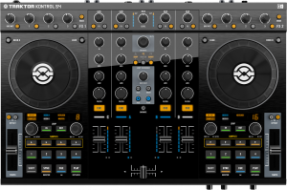](http://cdn.digitaldjtips.com/app/uploads/2010/11/09153004/traktor-kontrol-s4.png)Traktor is the most popular DJ software, so a controller designed by its makers specially for it is bound to be big news.

**Traktor Kontrol S4**

*Price:*[US$899](http://www.amazon.com/gp/product/B004A95HDW?ie=UTF8&tag=pbmo-20&linkCode=as2&camp=1789&creative=390957&creativeASIN=B004A95HDW) / [£749](http://www.amazon.co.uk/gp/product/B004A95HDW?ie=UTF8&tag=didjti-21&linkCode=as2&camp=1634&creative=19450&creativeASIN=B004A95HDW) / [€877](http://www.dolphinmusic.co.uk/product/46357-native-instruments-traktor-kontrol-s4.html?locale=de_DE)

*Rating:*[rating=5]

Supplied DJ software: Traktor Pro 2 (after April 1 2011), Traktor S4 Edition (free upgrade); Decks usable with supplied software: 4; Sound card: yes; Phono/line inputs: 2; Physical channels: 4; Booth/record out: no; Mic in: yes; Power: USB/external; Size & weight: 19.7 x 12.7 x 2″ (50 x 32.3 x 5.1cm), 10.3lb (4.7kg)

*They say:* Forget what you know about DJ controllers and DJ software. Traktor Kontrol S4 was designed from its conception as a fully integrated system where software and hardware are fused in perfect harmony.

*We say:* High quality unit, pretty large but light, good solid jogs, lots of features, and of course tight integration with Traktor. For this price we’d like to see XLR outs and separate booth monitor, but their lack is made up for by sample decks and other new features. Most popular DJ controller among our readers.

*See it at:* [Amazon.com](http://www.amazon.com/gp/product/B004A95HDW?ie=UTF8&tag=pbmo-20&linkCode=as2&camp=1789&creative=390957&creativeASIN=B004A95HDW), [Amazon.co.uk](http://www.amazon.co.uk/gp/product/B004A95HDW?ie=UTF8&tag=didjti-21&linkCode=as2&camp=1634&creative=19450&creativeASIN=B004A95HDW), [Dolphin Music (Europe)](http://www.dolphinmusic.co.uk/product/46357-native-instruments-traktor-kontrol-s4.html?locale=de_DE)

[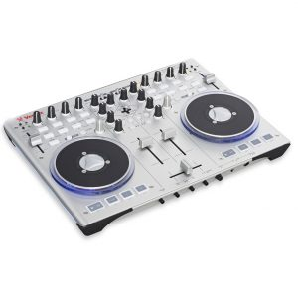](http://cdn.digitaldjtips.com/app/uploads/2011/02/09152615/vestax-cvi-100-mk-ii.jpg)More logically laid out but with blue underlighting that may not be to everyone’s taste: The Vestax VCI-100 MkII.

**Vestax VCI-100 MkII**

*Price:*[US$630](http://www.amazon.com/gp/product/B0046OY64C?ie=UTF8&tag=pbmo-20&linkCode=as2&camp=1789&creative=390957&creativeASIN=B0046OY64C) / [£399](http://www.juno.co.uk/products/vestax-vci-100-mkii-usb-midi-dj-controller/407589-01/?currency=GBP&ref=ddjt) / [€467](http://www.juno.co.uk/products/vestax-vci-100-mkii-usb-midi-dj-controller/407589-01/?currency=EUR&ref=ddjt)  
*Rating:*[rating=4]

Supplied software: Traktor LE; Decks usable with supplied software: 2; Sound card: yes; Phono/line in: no; Physical channels: 2; Booth/record out: yes; Mic in: no; Power: USB/external; Size & weight: 14.1 x 10.6 x 1.5″ (368 x 270 x 38mm), 4.4lb (2kg)

*They say:* Over the years as the entire DJ scene made its shift to computer based DJing, we kept collecting requests and demands for a new model. Here it is: VCI-100 MkII.

*We say:* It’s lighter, still well made, the jog wheels have torque controls, it’s better laid out than the originals, it looks the part and it’s a great compact size. Misses mic and external inputs at this price point, though.

*See it at:* [Amazon.com](http://www.amazon.com/gp/product/B0046OY64C?ie=UTF8&tag=pbmo-20&linkCode=as2&camp=1789&creative=390957&creativeASIN=B0046OY64C), [Juno.co.uk (UK, rest of Europe, world)](http://www.juno.co.uk/products/vestax-vci-100-mkii-usb-midi-dj-controller/407589-01/?currency=GBP&ref=ddjt)

**Conclusion**

The DJ controller market is moving fast, and manufacturers are racing hand over foot to try and differentiate their products. We’re in a period of change: I can’t see it being acceptable to offer a four-deck controller with two-deck software for much longer, for instance.

With the extra price of 4-deck models comes the expectation of extra features – at the very least a microphone input and following that, the ability to plug some kind of external source or sources through the unit, even if it is just that – an emergency “thru” so you can have your iPod ready to take over if you suffer a crash while DJing.

Some of the new units, particularly the Numark NS6 and Reloop Jockey 3, look really promising, but there’s absolutely no point waiting for the next big thing if you’re in the market for a controller today.

There are models here on open sale now that can keep you happily being creative for years, so take your pick from what’s available in your territory and get out there DJing.

Good luck – and let us know how you get on.

*Do you agree with our ratings? Are there any controllers we’ve left out you’d like to see included? Have you had good or bad experiences with any of these controllers? Please let us know in the comments.*